**WEDC Website**

**Joseph Pace**

**Abdulrahman Lawal**

**Maegan Doherty**

**Michael Ferro**

**Table of Contents**

**Homepage………………………………………………………………………2-4**

**Directory…………………………………………………………………………4-6**

**Events……………………………………………………………………………..6-7**

**Articles…………………………………………………………………………..7-8**

**Homepage**





**HEADER BAR**

* **in order to change the color of the bar, you go to the style section (which is under the <head> section) and change background-color**
* **in order to change the text style, you go to the style section and change font-family**
* **to change the alignment of the text, go to text-align**
* **in order to add another tab to the bar, you go to the text under <nav id=”bar”>. Then you copy one of the already created bars, and change the names however desired. Make sure to link it to a different html sheet**
* **to change the text in the bar, you go to the <header> tag. Then you change the text between the <h1> tags.**

**BODY**

* **to change the text, you go the <div> tags and edit the text to your preference**
* **to change the text-style you go to the style element <div> under the <head> tag, then you change font family**
* **to change the text color, you add a color element to the <div> style**
* **to change the text at the top of the text, you go to the <h3> tag and edit the text**
* **to change the text-style, you go to the <h3> tag and change it**
* **to change the color, you add a color element to the <h3> style**
* **to add a background color, you make a body element in the style section, then you pick a color**
* **to add additional text to the body, you go below the </div> tag and you start your addition texts from there**

**Directory page**

**This Section will be focusing on the Directory page which has information about different workers with name labels and pictures.**

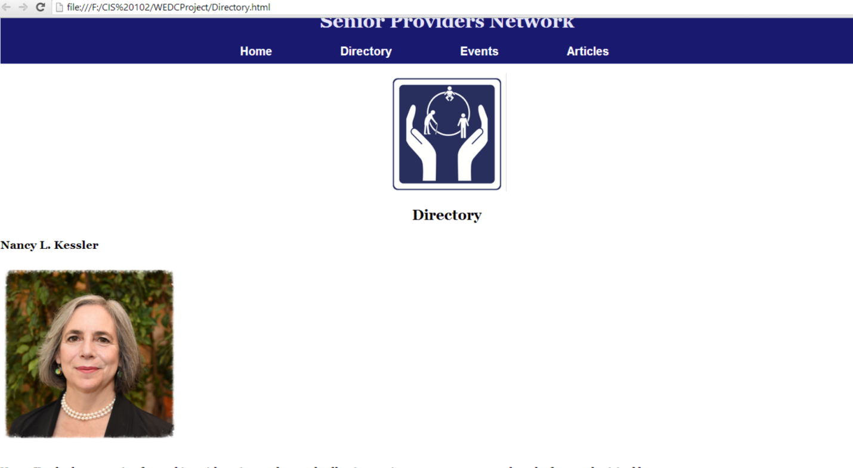

**This is the main section of code that will be used to add a new person or to edit an image or text. There is an identical piece of code for each person on the directory page. If you want a new person added into this page simply copy this piece of code shown below and paste it at after the </div> <br>.**

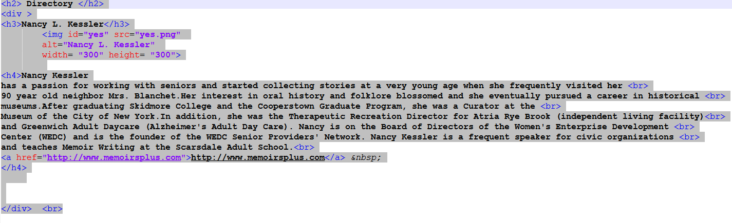

**Now in <h3> is where you will put the workers name example below you put the name in between <h3> and </h3> so it will look like this <h3>NameOfWorker</h3>.**



**Next is adding an image of the worker. For this section you start of with <img id="yes" the id="yes" allows the images to have the same format. the src= is where you put the name of the picture with the type of picture whether it be a jpg or png, For example if the name of the picture is hello and it is a png you would put src="hello.png" and your picture will be shown when you load up the site. For the alt="" you can put the name of the person since this is just used in case the picture is not loaded. In order to adjust the size of the picture you simply change either width ="" or height="" to change the height or width to fit your accommodations.**

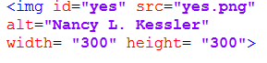

**In order to change the piece of text below the picture you can just delete the text in after <h4> but before the <a href=. The text you put there will go under the picture of the worker.**

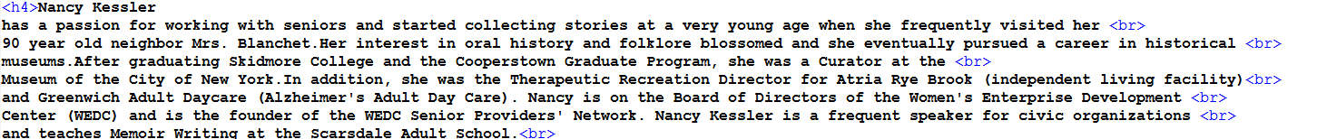

**In <h4> towards the end is the link that goes along with the worker that goes into more detail. This section begins <a href and ends at </h4> you put the link to the website that you want after href=""> then you put the name of the link so people can thee the name of the link and know where it will take them too. After you have <a href="ww.Website.com>www.Website.com you end it with </a> &nsp;**

**you should have a complete sections with a name picture and text with a link now you just have to end that section by putting </div> <br>.**

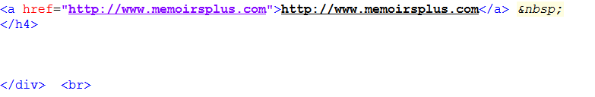

**EVENTS**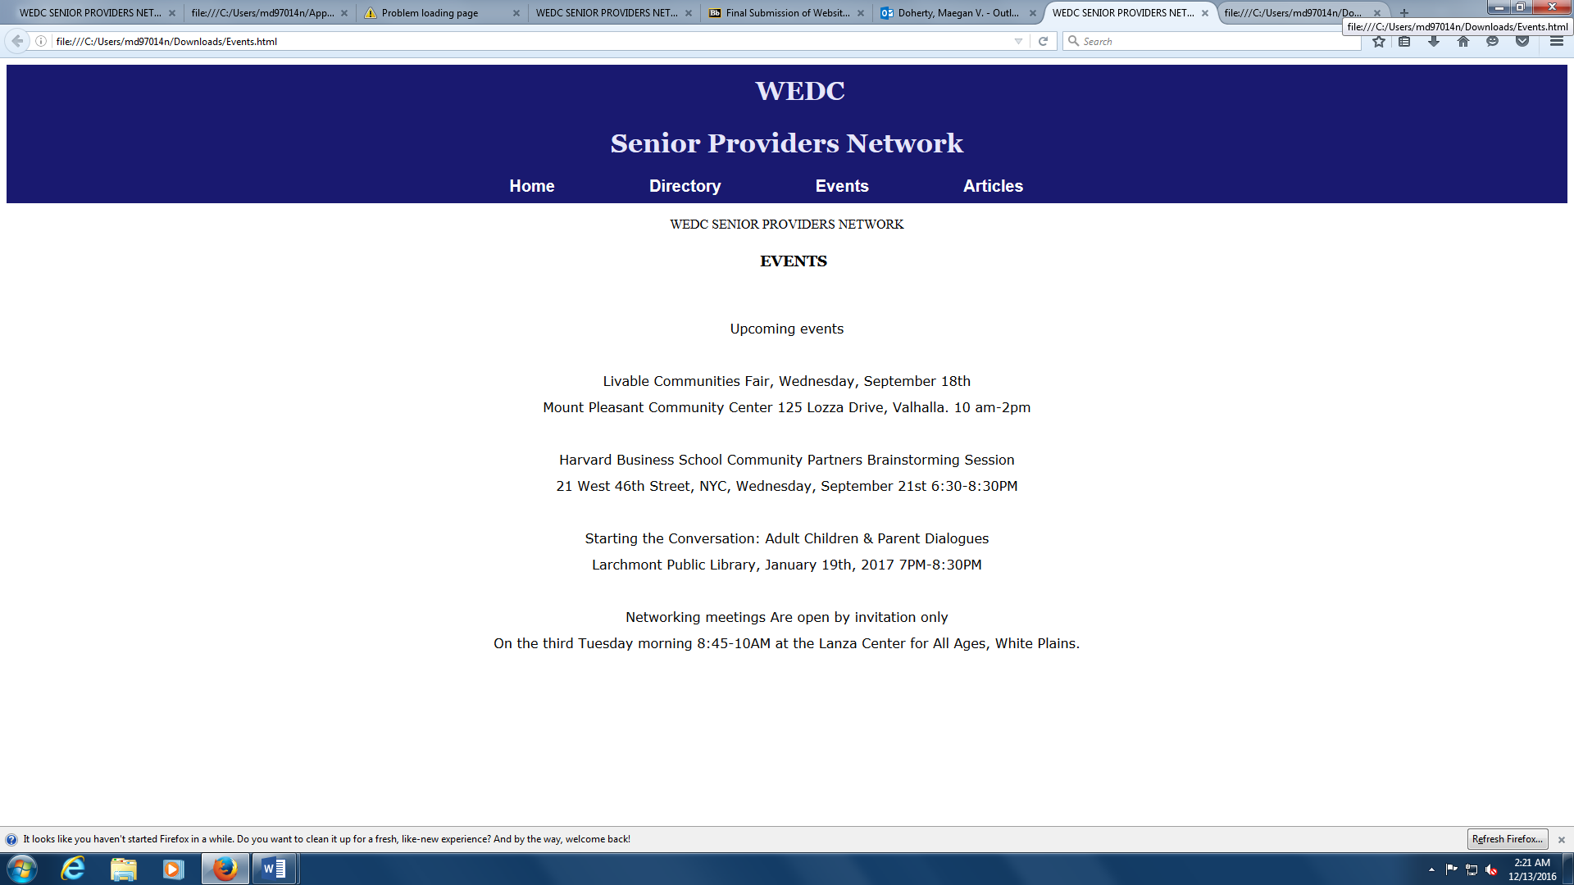

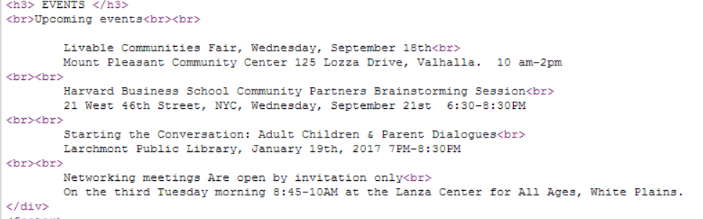

**In order to change the title you have to change what is inside the <h3> tag and end it with </h3>**

**<h3> EVENTS </h3>**

**Adding an event**

**<br>Upcoming events<br><br>**

**Below this type the event you want to add, then add the <br> tag to create a new line/break. Then to separate events add 2 <br> like shown above to maintain the same spacing between events.**

**Articles**

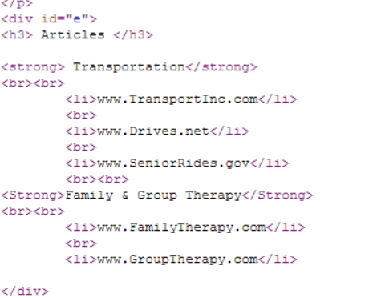

**To change the title of the article you change what is in between<strong></strong> and if you want to add or change a website within the title you change what is in the middle of <li></li> and after adding a new website to the list add a <br> to maintain the proper spacing.**